Ensemble Learning

Ensemble Learning
Ensemble learning combines multiple learners to improve predictive performance. It has been adopted in response to issue resulting from limited datasets.
Ensemble learning is a machine learning technique that aggregates two or more learners (e.g. regression models, classification models, neural networks) in order to produce better predictions. In other words, an ensemble model combines several individual models to produce more accurate predictions than a single model alone.
Some terminology: base learner, base model, and base estimator refer to the individual model or models used in ensemble algorithms. Base learner divides into weak learner and strong learner. Weak model or learners are defined as those that perform a little better than random guessing (random guessing yields 50% accuracy). By contrast, strong model or learner achieve great predictive performance, which is formalized as equal to or greater than 80% accuracy.

Bias-variance trade-off
Bias-variance trade-off is a well-known problem in machine learning and a motivation behind many regularization techniques. We can define them as:
- Bias: measures the average difference between predicted values and true values. As bias increases, a model predicts less accurately on a training dataset. High bias refers to high error in training. Bias signifies underfitting, when the model is too simple to capture pattern in a dataset.
- Variance: measures the difference between predictions across various realizations of a given model. As variance increases, a model predicts less accurately on unseen data, High variance refers to high error during testing and validation. Variance signifies overfitting, when the model is too complex it performs well on training but not the test.
Bias and variance thus inversely represent model accuracy on training and test data respectively. We reduce bias with optimization and variance with generalization attempts. The trade-off being making a model more complex reduce bias but increase variance. Conversely, making a model simpler reduce variance but increase bias. These are two of three terms that comprise a model’s total error rate, the third being irreducible error. This third term denotes error resulting from randomness in a dataset. The sweet spot where bias is low enough to capture the pattern and variance is low enough to generalize to unseen data gives the lowest total error.

Many models versus one
Any model training algorithm consists of numerous variables, including training data, hyperparameters, etc. that affects the model’s total error. Thus, even a single training algorithm can produce different models, each with their own bias and variance. By combining several diverse models, ensemble algorithms can yield a lower overall error rate while retaining each individual model’s own complexity and advantages.
Research suggests that, in general, the greater diversity among combined models, the more accurate the resulting ensemble model. Research also suggests that ensembles comprised of diverse overfit models outperformed single regularized models.

Types of Ensemble Models

Base Models
- Parallel: a method that train each base learner apart from the others. Parallel ensembles train base learners in parallel and independent of one another
- Sequential: a method that train a new base learner so that it minimizes errors made by the previous model trained in the preceding step. In other words, sequential methods construct base models sequentially in stages
The visual representation of each methods is as follows:
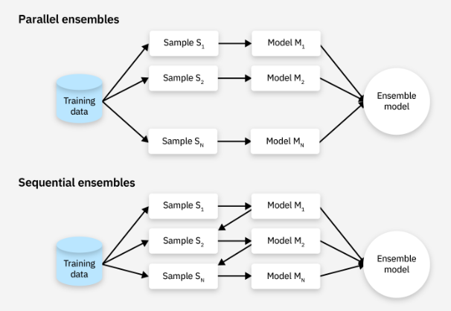

Voting
There are different techniques used in combining base learners into a final learner, with the most common being voting. Voting consolidates base learner predictions by majority voting. Majority voting considers each base learner’s prediction for a given data instance and outputs a final prediction determined by whatever the majority of learners predict. An extension of this is weighted majority voting that gives greater weight to certain learner’s predictions over others. For regression problems, the final learner will use average predictions.

Ensemble learning techniques
Three of the most popular ensemble learning techniques are bagging, boosting, and stacking. These together exemplify distinctions between sequential, parallel, homogenous, and heterogeneous types of ensemble methods.

Bagging
Bagging is a homogenous parallel method sometimes called bootstrap aggregating. It uses modified replicates of a given training data set to train multiple base learners with the same training algorithm.
More specifically, bagging uses a technique called bootstrap resampling to derive multiple new datasets from one initial training dataset in order to train multiple base learners. Bootstrap resampling copies n data instances from that set into a new subsample dataset, with some initial instances appearing more than once and others excluded entirely. Repeating this process x times produced x iterations of the original dataset, each containing n samples from the initial set. Each iteration of the initial set is then used to train a separate base learner with the same learning algorithm. The visual representation is as follows:
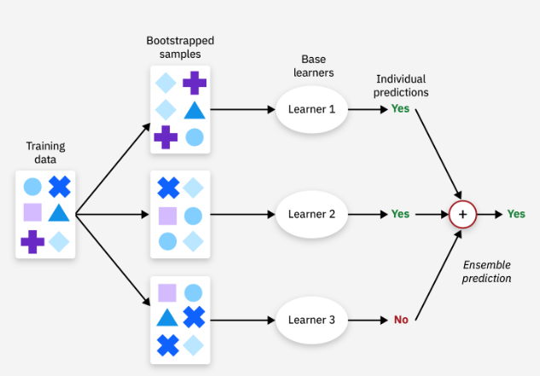
Random forest is an extension of bagging that specifically denotes the use of bagging to construct ensembles of randomized decision trees.

Stacking
Stacking or stacked generalization is a heterogenous parallel method that exemplifies what is known as meta-learning. Meta-learning consists of training a meta-learner from the output of multiple base learners. Stacking specifically trains several base learners from the same dataset using a different training algorithm for each learner. Each base learner makes predictions on an unseen dataset, these first model predictions are then compiled and used to train a final model, being the meta-model. It is visually pictured as follows:
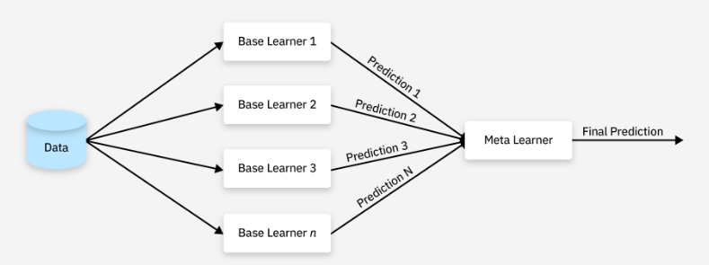
Note the importance of using a different dataset from that used to train the base learners in order to train the meta-learner, Using the same dataset to train both base learners and the meta-learner can result in overfitting. This can require excluding data instances from base learners training data to serve as its test data, which in turn becomes training data for the meta-learner. We can use techniques such as cross validation to ensure these datasets do not overlap. When using cross validation, say we create 5 folds, we train the base learners on the same 4 folds and use the last 1 fold for the prediction, that will be put into the meta-learner.

Boosting
Boosting algorithms are a sequential ensemble method. Boosting has many variations, but they all follow the same general procedure. Boosting trains a learner on some initial dataset, d. the resultant learner is typically weak. Boosting then samples instances from the initial dataset to create a new dataset, d2. Boosting prioritizes misclassified data instances from the first learner to be put on d2, A new learner is then trained on d2. Then a third dataset d3 is compiled from d and d2, prioritizes the second learner’s misclassified instances. The process repeats n times to produce n learners. Boosting then combines and weights all the learners together to produce final predictions.
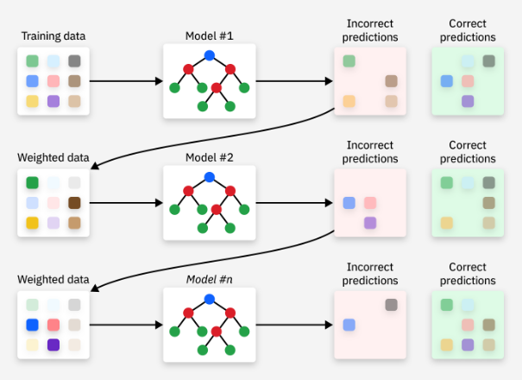

Boosting algorithms differ in how they prioritize misclassified data instances when creating new dataset. Two of the most common methods are:
- Adaptive boosting (AdaBoost): weights model errors. That is, when creating a new iteration of a dataset for training the next learner, AdaBoost adds weights to the previous learner’s misclassified instances, causing the next learner to prioritize these samples.
- Gradient boosting: uses residual errors when training new learners. Instead of using a resampled data, gradient boosting trains new model on the residual error from previous model. The final learner then adds up the predicted values on each model for the final predictions. It is basically doing gradient descent but with trees instead of coefficients.
Small numeric example of gradient boosting:
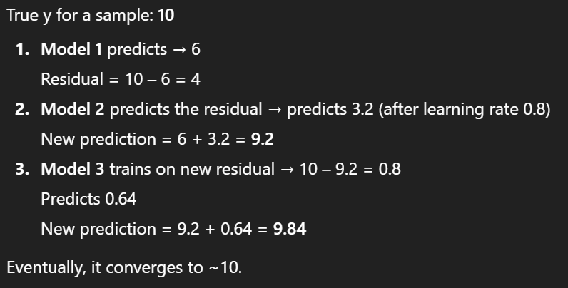

Bias-Variance angle
In terms of bias-variance trade-offs, each technique helps with a certain area:
- Bagging lowers variance because averaging the predictions over many models cancels out fluctuations. It works best with high-variance models, like deep decision trees. However, bias stays unchanged as each tree is the same and all have the same simplicity.
- Boosting lowers bias as each new learner corrects mistakes from the previous model. Variance will be slightly increased, but small learning rate and regularization help. Works best with weak learners, because sequential correction adds the complexity gradually. However, using strong learner leads to overfitting very quickly.
- Stacking depends on the base and meta learner. If base learners are biased, meta learner can reduce bias. If base learners are high variance, meta learner can reduce variance. Essentially, stacking utilize diversity to minimize both bias and variance. It is flexible, but needs careful training.

References
IBM: https://www.ibm.com/think/topics/ensemble-learning

